Main Section: Book Illustration
Sub Sections: (Below)

Illustration Styles
What it will contains
- Cartoon style
- Watercolor style
- Digital painting
- 3D style
- Minimal style
2. Character Design
What it will contains
- Main character creation
- Character expressions
- Character sheets
- Character development

3. Activity Book Illustration
- Coloring books
- Puzzle books
- Educational activity books

4. Storybook Illustration
- Full page illustrations
- Double page spreads
- Scene illustrations
- Background design
—----------- The End of The Page —-----------

Example: Children's Book Illustration
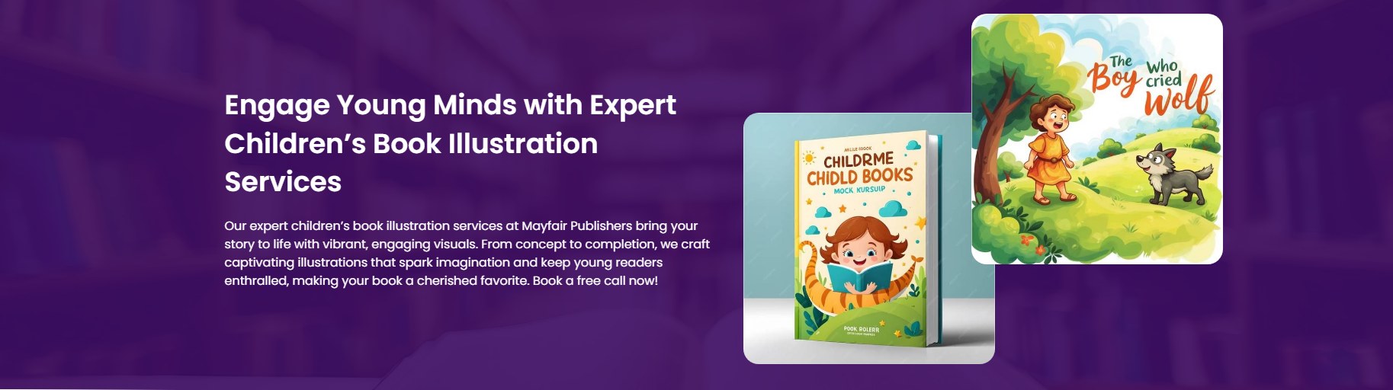
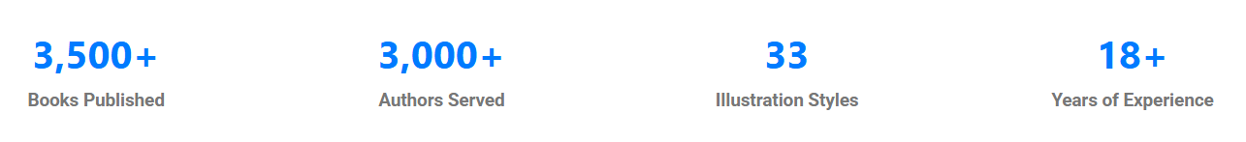
This is how our Children's Book Illustration page will begin but change the wordings and style.

Illustration Styles Portray & Content

Show All Types of Illustrations Styles and Sample
- Cartoonish Illustration Style
- Realistic Illustration Style
- Flat/Abstract Illustration Style
- 3D/Detailed Illustration Style
- Comic Book Illustration Style
- Watercolor Illustration style

Choose The Right Illustration Style For Your Story.

Character Design
Heading:
"Create Characters Children Remember"
Content:
Explain:
We develop characters based on personality, emotions, age group, and story requirements.
Character Creation
Contains:
- Character concept
- Appearance
- Clothing
- Personality traits
- Character references

Character Expressions
Contains:
- Happy expressions
- Sad expressions
- Angry expressions
- Surprise expressions

Character Sheets
Contains:
- Front view
- Side view
- Back view
- Different poses
- Expression references

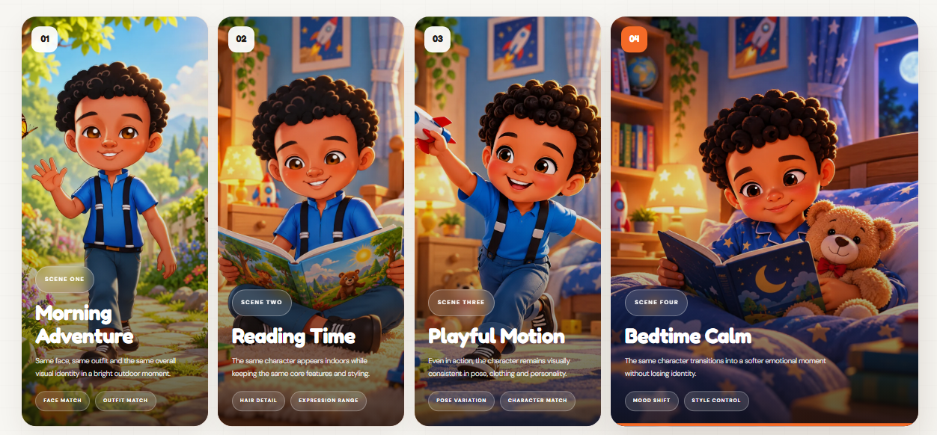
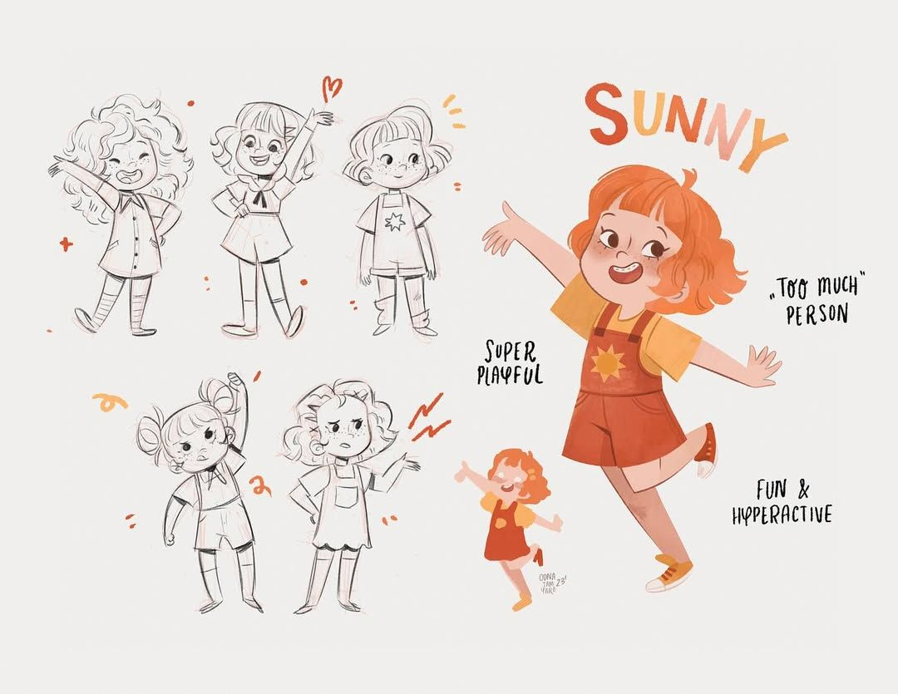
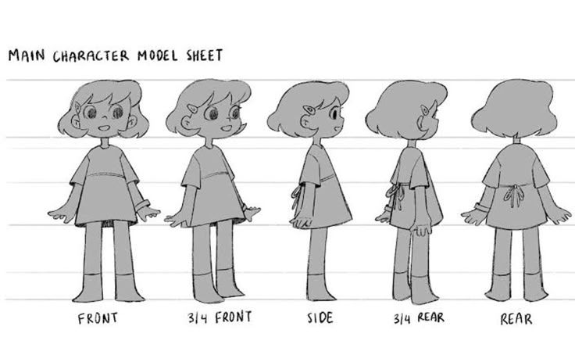
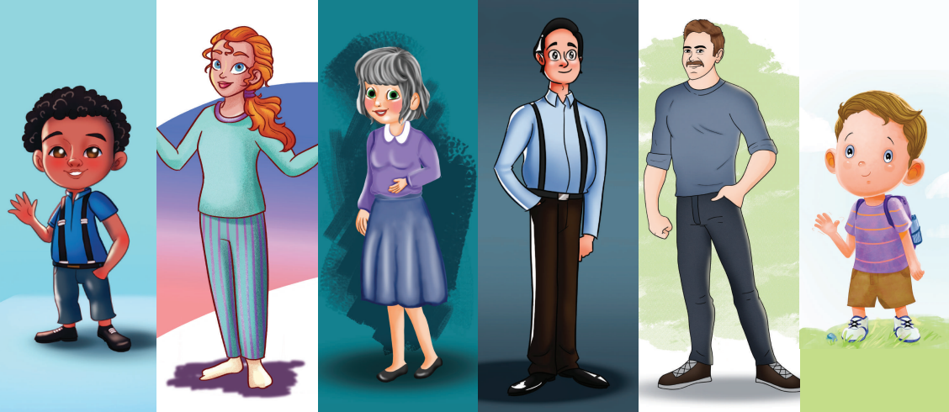
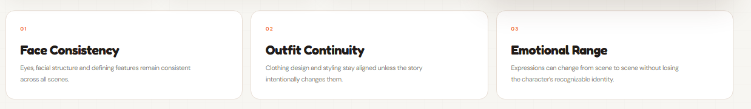

Activity Book Illustration

Heading:
"Creative Illustrations For Interactive Children's Activity Books"

Content:
We create engaging visuals for activity based children's content.

Coloring Books
Contains:
- Line drawings
- Simple characters
- Printable pages
https://www.pinterest.com/pin/867224472018098406/
https://www.pinterest.com/pin/867224472018098415/
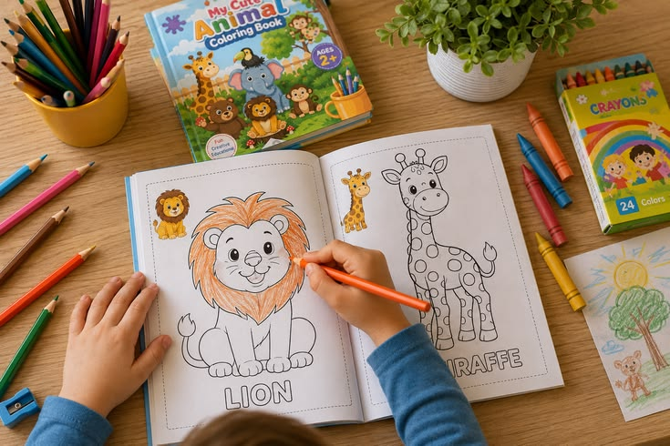
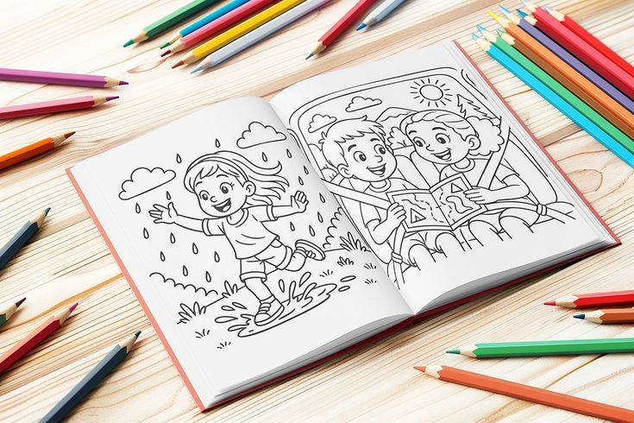
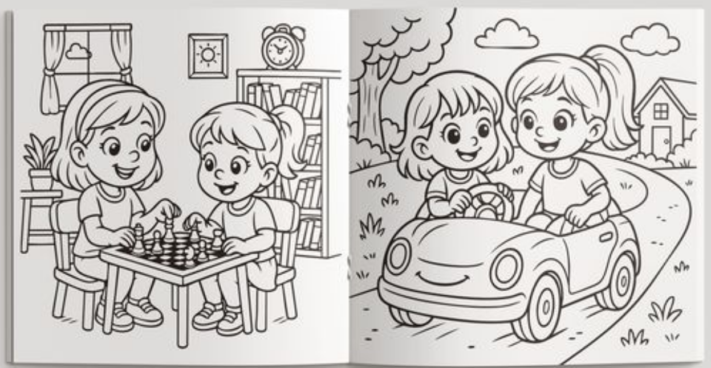
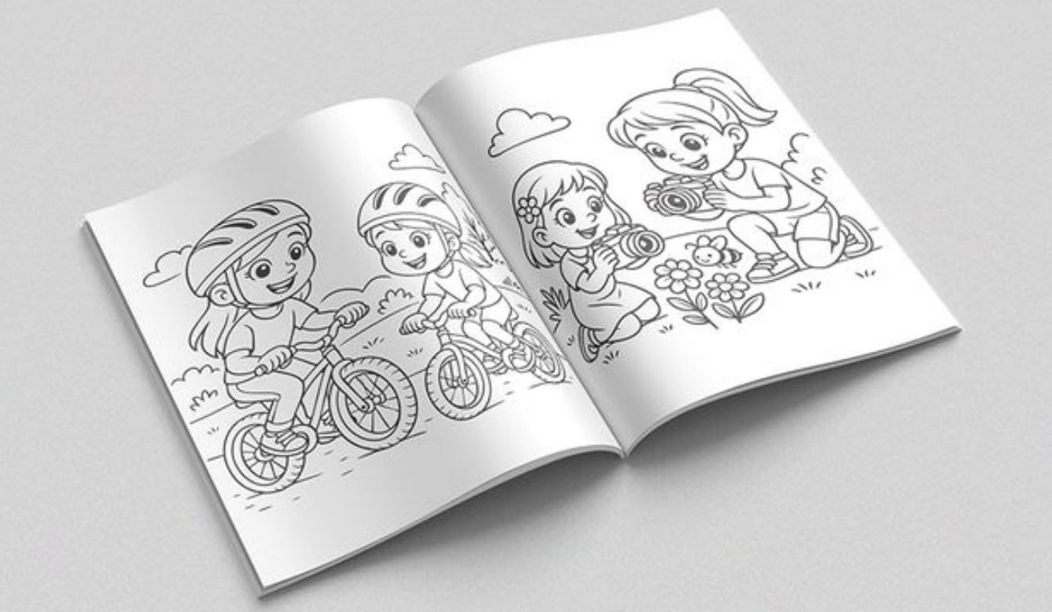
Find some more and show the colouring books to portray the section more visual appealing.

Puzzle Books
Contains:
- Maze designs
- Matching activities
- Hidden objects
- Games

Educational Activity Books
Contains:
- Learning pages
- Alphabet activities
- Number activities
- Skill based worksheets


